1. **Key Pad Flow Chart (Get_Pressed_Key)**

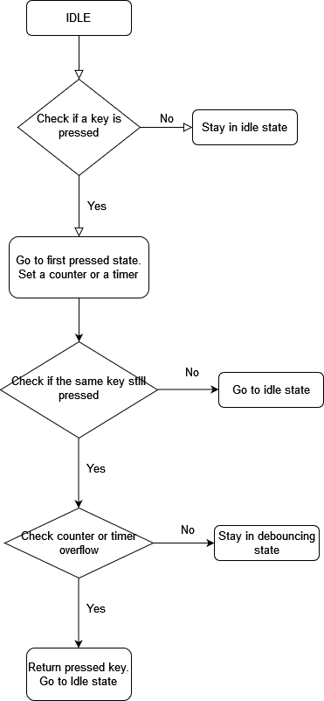

**2- LCD Flow Chart (LCD_Display_Character)**

Stay in Wait_Write state

Check waiting timer over flow

-Write data to bus

- Go to Wait_Write state

-Enable LCD

- Go to Wait_Enable state

Yes

Stay in Wait_Enable state

Check waiting timer over flow

Yes

No

Stay in Wait_Init state

Check waiting timer over flow

-Set register select pin.

- Set read\write pin.

- Go to Wait_Init state.

-Go to Idle state

Stay in Wait_Disable state

Check waiting timer over flow

-Disable LCD

- Go to Wait_Disable state